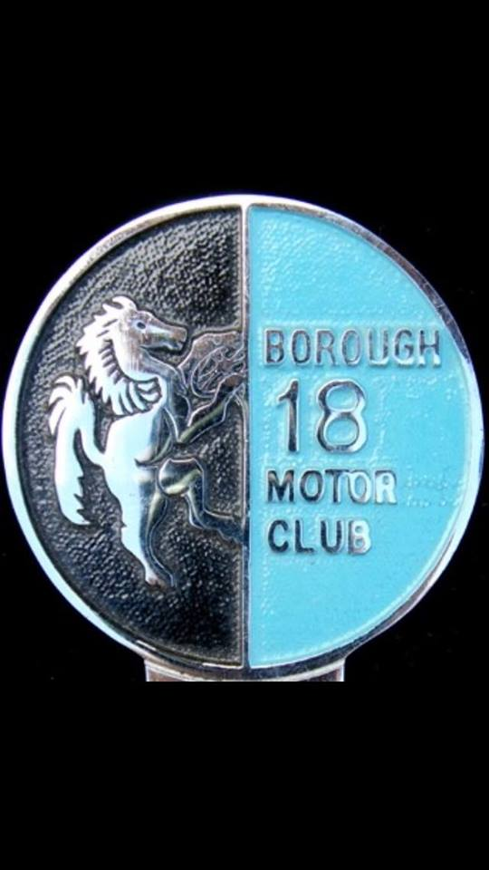

Borough 18 Motor Club/ Weald Motor Club

12-Car Rally
18th October 2019

45 miles of classic Weald roads on map 188

Start: Crown Point Inn. Seal Chart Ref: 576556½

7pm for 8pm Start Entry: £ 15

Rally insurance available on the night by JELF Insurance Services (£16)

Navigation will be straightforward but will require accurate plotting.

Thanks to the generosity of Utting Estates Limited, a degree of financial support will be available during this current series in order to stimulate interest for beginner crews. The introduction of 12-Car Rallies many years ago was intended to encourage newcomers into rallying and today this is still very much the principle aim. In this series beginners will be very welcome and a subsidy will be available on each round as a contribution towards their expenses. (See Regs.)

Entries to: Roger Keene See entry form below roger.keene@ntlworld.com

* If you are unable to enter, then please come along and help with marshalling.

Marshals please contact: Dave Clark 01474 833496 (home)
07967 627833 e-mail: daveclark1949@btinternet.com

http://borough18motorclub.weebly.com/

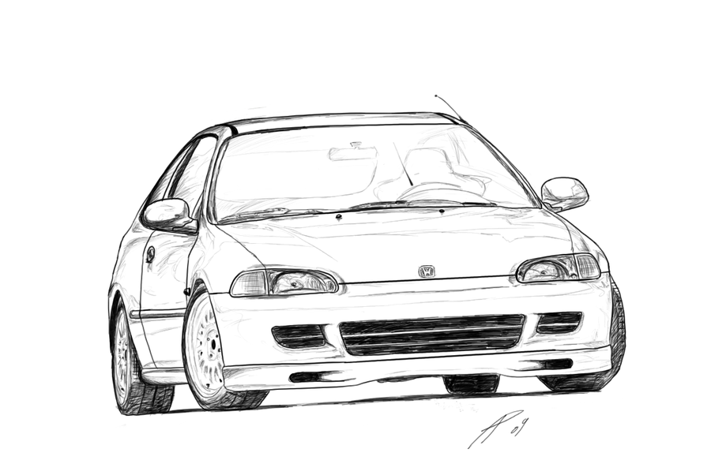

BOROUGH 18 MC 12 CAR RALLY 18th October 2019

ENTRY FORM PLEASE PRINT Entry fee: £ 15

Post to: 39 New Road London SE2 0QH

or e-mail: roger.keene@ntlworld.com

Please make payment (£15) direct to Nationwide
sort code 07-04-36 account no 15212542
giving : OCT 12 CAR and then the DRIVERS surname as reference, otherwise we will not be able to process your entry.

Driver’s Name ……………………………………………………………………..

Address ……………………………………………………………………………....

……………………………………………………Postcode…………………………

Tel No………………………………. e-mail …………………………………

Navigator’s Name ………………………………………………………………….

Address………………………………………………………………………………

……………………………………………………Postcode…………………………

Tel No. ………………………………. e-mail …………………………………

Car Make/Model………………………………..…. c.c. ……………

Registration No. ………………………………..… Colour ……………………….

Class entered: Expert/ Semi/ Novice/ Beginner

Insurance
I will be using the JELF insurance facility …yes/ no (To be paid on the night)

or Private Insurance – Company Name……………….....………………

Policy No. ……………………

Please give these details of who can be contacted in the event of an accident.

Name ……………………………… Tel No. ……………………..

Please sign the following Declaration of Indemnity:

(i)
I declare that I have been given the opportunity to read the General Regulations of Motorsport UK and these Additional Supplementary Regulations and agree to be bound by them. I declare that I am physically and mentally fit and competent to take part in the event. I understand that motor sport is dangerous and accidents causing death, injury, disability and property damage can and do happen. I understand that these risks may give rise to my suffering personal injury or other loss and I acknowledge and accept these risks. In consideration of the acceptance of this entry I agree that neither any one of or any combination of Motorsport UK and its associated clubs, the organisers, the land owners or other occupiers, the promoters and their respective officers, servants, representatives and agents (the “Parties”) shall have any liability for loss or damage which may be sustained or incurred by me as a result of participation in the Event. Nothing in this clause is intended to or shall be deemed to exclude or limit liability for death or personal injury. To the fullest extent permitted by law I agree to indemnify and hold harmless each of the Parties in respect of any loss or damage whatsoever and howsoever arising from my participation in the Event.
I declare that to the best of my belief that we (driver and navigator) possess the standard of competence necessary for an event of the type to which this entry relates and that the vehicle entered is suitable and roadworthy for the event having regard to the course and the speeds which will be reached
(ii)
I declare that the use of the vehicle hereby entered will be covered by insurance as required by the law which is valid for such part of this event as shall take place on roads as defined by the law.

Drivers Signature ……………………………………….. Age if under 18 …...…………

Motor Club ………………………………...Card No. ……………………………………

Navigator’s Signature ……………………………………… Age if under 18 ……………

Motor Club…………………………………Card No. …………………………Date…………….

THIS ENTRY IS MADE WITH MY CONSENT (if aged under 18):

Parent/Guardian of DRIVER Signature ………………………………………………..

Full Name of Parent/Guardian …………………………………………………………….

Relationship …………………………………………. Tel. No: ………………………….

Address …………………………………………………………………………………….

Parent/Guardian of NAVIGATOR Signature …………………………………………

Full Name of Parent/Guardian …………………………………………………………….

Relationship …………………………………………. Tel. No: ………………………….

Address …………………………………………………………………………………….

